**MID TERM QUESTION :2025**

**QUESTION : 1:**

**INPUT:**

**Write a Python script that does the following**:

* + Prints the message: "Welcome to Python Programming!".
  + Declares three variables: an integer, a float, and a string. Assign values to these variables.
  + Displays the data type of each variable using the type() function.
  + Uses a single-line comment to describe each operation.

**SOLUTION:**

# Prints the message "Welcome to Python Programming!"

print("Welcome to Python Programming!")

# Declares three variables: an integer, a float, and a string, and assigns values to them

my_int = 10 # Integer variable

my_float = 20.5 # Float variable

my_string = "Hello, Python!" # String variable

# Displays the data type of each variable using the type() function

print(type(my_int)) # Output the data type of the integer

print(type(my_float)) # Output the data type of the float

print(type(my_string)) # Output the data type of the string

**OUTPUT:**

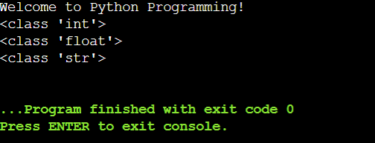

**QUESTION :2:**

**INPUT:**

**Write a Python script to solve the following problem:**

* + Take two numbers as input from the user.
  + Perform and display the results of the following operations:
    - Addition, Subtraction, Multiplication, Division, and Modulus.
  + Check if the first number is greater than the second and display the result using a relational operator.
  + Use a logical operator to check if both numbers are positive and display the result.

**SOLUTION:**

# Taking two numbers as input from the user

num1 = float(input("Enter the first number: "))

num2 = float(input("Enter the second number: "))

# Performing arithmetic operations

addition = num1 + num2

subtraction = num1 - num2

multiplication = num1 * num2

# Ensure no division by zero

if num2 != 0:

division = num1 / num2

modulus = num1 % num2

else:

division = "undefined (cannot divide by zero)"

modulus = "undefined (cannot compute modulus with zero)"

# Displaying the results of arithmetic operations

print(f"Addition: {num1} + {num2} = {addition}")

print(f"Subtraction: {num1} - {num2} = {subtraction}")

print(f"Multiplication: {num1} * {num2} = {multiplication}")

print(f"Division: {num1} / {num2} = {division}")

print(f"Modulus: {num1} % {num2} = {modulus}")

# Checking if the first number is greater than the second

if num1 > num2:

**OUTPUT:**

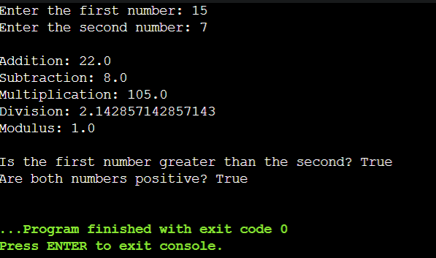

**QUESTION:3:**

**INPUT: Write a Python program to evaluate a grade:**

* + Take a percentage as input from the user.
  + Determine the grade using the following criteria:
  + A: 90% and above
  + B: 80%-89%
  + C: 70%-79%
  + D: 60%-69%
  + F: Below 60%
  + Use if-elif-else statements to implement the logic.
  + Use indentation properly and ensure the program handles invalid input gracefully.

**SOLUTION:** **# Function to determine the grade based on the percentage**

**def determine_grade(percentage):**

**if percentage >= 90:**

**return "A"**

**elif percentage >= 80:**

**return "B"**

**elif percentage >= 70:**

**return "C"**

**elif percentage >= 60:**

**return "D"**

**else:**

**return "F"**

**# Input from user with validation**

**while True:**

**try:**

**percentage = float(input("Enter the percentage: "))**

**if 0 <= percentage <= 100: # Check if the input is a valid percentage**

**grade = determine_grade(percentage)**

**print(f"The grade for {percentage}% is: {grade}")**

**break**

**else:**

**print("Please enter a valid percentage between 0 and 100.")**

**except ValueError:**

**print("Invalid input. Please enter a numeric value for the percentage.")**

**OUTPUT:**

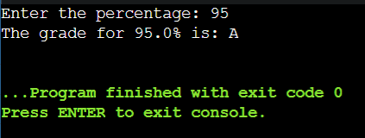

**QUESTION:4:**

**INPUT:**

**Write a Python script to print a multiplication table:**

* + Take an integer as input from the user.
  + Print the multiplication table for the given number up to 10.
  + Use a while loop to generate the table.
  + Add a feature to break the loop if the user enters a negative number.

**SOLUTION:**

**# Take integer input from the user**

**number = int(input("Enter a number: "))**

**# Check for negative number**

**if number < 0:**

**print("Negative number entered. Exiting...")**

**else:**

**# Initialize a counter for the while loop**

**i = 1**

**# Use a while loop to generate the multiplication table**

**while i <= 10:**

**print(f"{number} x {i} = {number * i}")**

**i += 1**

**OUTPUT:**

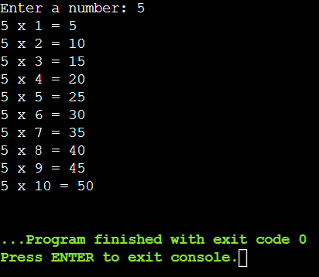

**QUESTION :5:**

**INPUT:**

**Write a Python script to display a pattern:**

*

* *

* * *

* * * *

* * * * *

* + Use nested loops to generate the pattern.
  + Include comments explaining the role of each loop.

**SOLUTION:**

**# Outer loop to control the number of rows**

**for i in range(1, 6):**

**# Inner loop to print '*' for each column in the current row**

**for j in range(i):**

**print('*', end=' ') # Print '*' followed by a space, without newline**

**print() # Move to the next line after printing all '*' for the current row**

**OUTPUT:**

